

**SEMI AUTOMATIC VOICE AND MOBILE CONTROLLED VEHICLE**

**Submitted by**

|  |  |
| --- | --- |
| **PRASANNA KUMAR.R** | **13BIC012** |
| **LOGESHWARAN.M** | **13BIC022** |
| **ARAVINDAN.B** | **13BIC023** |
| **SANTHOSH.N** | **13BIC030** |

***In partial fulfillment for the award of the degree***

***of***

**Bachelor of Engineering**

**in**

**Instrumentation and Control Engineering**

**Dr.Mahalingam College of Engineering and Technology**

**Pollachi – 642003**

**An Autonomous Institution**

**Affiliated to Anna University, Chennai - 600 025**

**APRIL 2016**

**MINI PROJECT REPORT**

BONAFIDE CERTIFICATE

who carried out the mini project work under my supervision.

|  |  |
| --- | --- |
| PRASANNA KUMAR R | 13BIC012 |
| LOGESHWARAN M | 13BIC022 |
| ARAVINDAN B | 13BIC023 |
| SANTHOSH N | 13BIC030 |

**Dr.Mahalingam College of Engineering and Technology**

**Pollachi – 642003**

**An Autonomous Institution**

**Affiliated to Anna University, Chennai -600 025**

**EXTERNAL EXAMINER**

**INTERNAL EXAMINER**

Submitted for the Autonomous End Semester Examination mini Project work

viva-voce held on ____________________

**Dr. K. Vijayakumar**

**HEAD OF THE DEPARTMENT**

Associate Professor

Instrumentation and control Engineering

Dr. Mahalingam College of Engineering and Technology, NPT-MCET Campus

Pollachi – 642003

**Mr. M. Ganeshan**

**SUPERVISOR**

Assistant Professor

Instrumentation and control Engineering

Dr. Mahalingam College of Engineering and Technology, NPT-MCET Campus

Pollachi – 642003

Certified that this mini project report of,

**“SEMI AUTOMATIC VOICE CONTROLLED AND MOBILE CONTROLLED VEHICLE”**

is the bonafide work of

**ABSTRACT**

The project is based on an objective to develop a modern technology vehicle for physical challenged people. The main aim of this project is to provide a remedy for the physically challenged people to travel in a smooth manner from one place to another. This technology will also create a tremendous change in the automobile world. The vehicle is developed in such a way that it can be operated in three modes 1) semi-automatic 2) mobile controlled and 3) voice controlled. The heart of the project is embedded system. Here it is programmed with the help of arduino.

The foremost aim of the project is to make an easy transportation facility for the physically challenged people. In 2015, survey says that almost 3% of population in India was handicapped peoples. Nowadays most of us were able to see peoples who were unable to move from one place to another. Though there are bikes or other vehicles to travel it is not more suitable and also creates many problem for the physically challenged. So this vehicle well suites as a primary remedy for the problem.

The other aim is to modernize the automobile world with the automated vehicle. In many countries most of the automobile companies were trying to develop an automated vehicle but every attempt fails at some point. Mercedes Benz is the first company to develop an automatic vehicle. When it is off-road the vehicle succeeded its test. When same comes to on road the vehicle fails. Most of the automobile companies were keen in developing an automated vehicle. In India Tata was the company which is developing an automatic car.

**ACKNOWLEDGEMENT**

We extend our gratitude to our management for having provided us with all facilities to build our project successfully. We express our sincere thanks to our honorable Secretary **Prof. C. Ramaswamy, M.E., F.I.V.,** for providing us with required amenities.

We feel happy to express our sincere thanks to our Director (Academic) **Dr. S. Vijayarangan, M.E., Ph.D.,** for his support and encouragement.

We express our thanks to our Principal **Dr. M. Ramakrishnan,M.E., Ph.D.,** who provided suitable environment to work with.

We express our gratefulness to **Dr. K. Vijayakumar, M.E.,Ph.D.,**Head of the Department, Instrumentation and Control Engineering for providing us kind advice during the development of the project.

Our hearty thanks to our internal guide **Mr. M.Ganeshan**.**, M.E.,** Assistant Professor (SS), Instrumentation and Control Engineering, MCET, for his constant support and guidance offered to us during the course of our project by being one among us.

We are committed to place our heartfelt thanks to all teaching and non-teaching staff members, lab technicians and all the noble hearts that gave us immense encouragement towards the completion of our project. Finally we thank almighty for bestowing the gifts of life on us and also for providing us the necessary help through his lovely creations in this Endeavour of us.

**LIST OF ABBREVIATIONS**

US : Ultrasonic sensor

IR SENSOR : Infrared sensor

BT MODULE : Bluetooth module

DC : Direct current

BT : Battery

MC : Microcontroller

MD : Motor Driver

CC : Car Chassis

Specs : Specifications

BT App : Blue Terms Application

BTV : Bluetooth Voicer

**TABLE OF CONTENTS**

1. **INTRODUCTION**........................................................................................................1

1.1 Block diagram...........................................................................................................2

2. **EXISTING MODEL**...................................................................................................3

2.1 Introduction...............................................................................................................3

**3. INFRARED SENSOR**.................................................................................................4

3.1 Introduction...............................................................................................................4

3.2 Photoelectric type IR sensor.....................................................................................4

3.3 Sensing mode............................................................................................................5

**4. POWER SUPPLY**.......................................................................................................7

4.1 Battery.......................................................................................................................7

4.2 Battery charger…………………………………………………..............................8

4.2.1 Types of battery charger........................................................................................9

4.2.1.1 Simple chargers...............................................................................................9

4.2.1.2 Fast chargers....................................................................................................9

4.2.1.3 Inductive chargers...........................................................................................9

4.2.1.4 Intelligent chargers…………………............................................................10

4.2.1.5 Motion powered chargers………………………..........................................11

4.2.1.6 Pulse chargers………………........................................................................11

4.2.1.7 Solar chargers………....................................................................................11

4.2.1.8 Time based (HI) chargers..............................................................................12

4.2.1.9 Trickle chargers………………….................................................................12

4.2.1.10 Universal battery chargers…….....................................................................13

4.2.1.11 USB based chargers……...............................................................................13

4.2.1.12 Power bank....................................................................................................13

**5**. **ULTRASONIC SENSOR**..........................................................................................15

5.1 Introduction...........................................................................................................15

5.2 Working of ultrasonic sensor................................................................................16

5.3 Specifications........................................................................................................16

**6**. **BLUETOOTH MODULE**........................................................................................17

6.1 Introduction...........................................................................................................17

6.2 Features...............................................................................................................17

6.3 Description..........................................................................................................18

6.4 Working………………………….......................................................................19

**7**. **MOTOR DRIVER**...................................................................................................20

7.1 Introduction.........................................................................................................20

7.2 Description………………………………………..............................................20

7.3 Working of motordriver......................................................................................21

7.4 Specifications...…………………………….......................................................21

**8. ARDUINO UNO**......................................................................................................22

8.1 Introduction.........................................................................................................22

8.2 General use of arduino.........................................................................................22

8.3 General features of arduinoUNO…………………………….............................22

8.4 Power (USB/power jack).....................................................................................23

8.5 Pins………….......................................................................................................23

8.6 Reset button…………….....................................................................................24

8.7 Power LED indicator……………………...........................................................24

8.8 Tx and Rx LED indicators……...........................................................................24

8.9 Main IC…………................................................................................................24

8.10 Voltage regulator………………………….........................................................24

**9. DC GEAR MOTOR**................................................................................................25

9.1 Introduction..........................................................................................................25

9.2 Specifications.......................................................................................................25

9.3 Working…………………………………………………....................................26

9.3.1 Back EMF………………………......................................................................26

9.3.2 Significance of back EMF….............................................................................27

**10. HARDWARE IMPLEMENTATION**...................................................................28

**11. PROGRAMMING OF ARDUINO**.......................................................................30

11.1 Algorithm.............................................................................................................30

**12.ADVANTAGES**........................................................................................................34

**13.DISADVANTAGES**..................................................................................................34

**14.CONCLUSION**….....................................................................................................34 **15.FUTURESCOPE**…..................................................................................................34

**LIST OF FIGURES**

Figure1 Infra Red sensor...................................................................................................6

Figure2 Batteries.............................................................................................................14

Figure3 Ultrasonic sensor...............................................................................................16

Figure4 Bluetooth module..............................................................................................17

Figure5 Motor driver.......................................................................................................21

Figure6 Arduino UNO.....................................................................................................23

Figure7 DC Gear Motor..................................................................................................25

Figure8 Final outlook......................................................................................................29

1. **INTRODUCTION**

This project is about a modern technology vehicle for physical challenged people. The foremost aim of the project is to provide a solution for the physically challenged people to travel in a smooth manner from one place to another without any difficulty. This technology will also create a tremendous change in the automobile world . Here, the vehicle is programmed in such a manner that it can be operated in three modes

1) Semi-automatic

2) Mobile controlled and

3) Voice controlled.

The heart of the project is embedded system. Here the project is programmed with the help of arduino which has ATMEGA 328 (microcontroller) .

Here we can easily switch over from one mode to another mode with the help of the mobile phone provided with clear data sheet. The mobile application used for controlling the vehicle is Blue Terms and BT voicer. For general purpose to select the modes we have to use the BT app and for the voice control alone we have to go for the BT voicer app.

For this vehicle it is provided with two DC geared motors which is connected with the help of two motor drivers L293D. When both the motor is running in same direction (i.e.) in clockwise direction the vehicle will be moving in the front and when the motors are running in the counterclockwise direction then the vehicle will be moving in the backside.

Similarly, when any one of the motors is rotating in any direction then the vehicle will be moving accordingly. This controlling of the motor driver is made through microcontroller. The motor driver helps in running the two dc motors. The motor driver is powered separately with a power bank which provides a supply of 5v.

BLOCK DIAGRAM

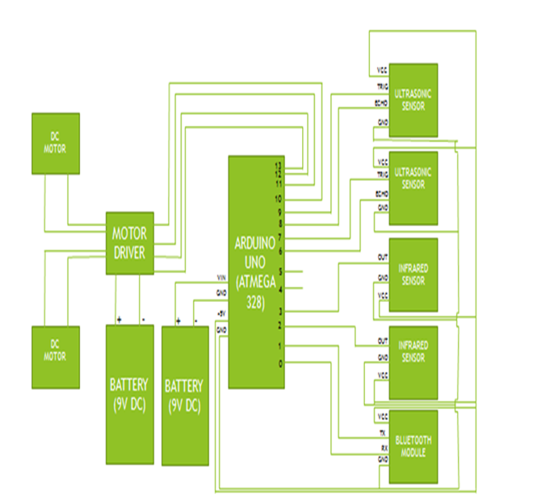

BLOCK DIAGRAM OF SEMI AUTOMATIC VOICE CONTROLLED AND MOBLIE CONTROLLED VEHICLE

**2. EXISTING MODEL**

**2.1 Introduction**

The foremost aim of the project is to make an easy transportation facility for the physically challenged people. In 2015, survey says that almost 3% of population in India was handicapped peoples. Nowadays most of us were able to see peoples who were unable to move from one place to another. Though there are bikes or other vehicles to travel it is not more suitable and also creates many problem for the physically challenged. So this vehicle well suites as a primary remedy for the problem.

The other aim is to modernize the automobile world with the automated vehicle. In many countries most of the automobile companies were trying to develop an automated vehicle but every attempt fails at some point. Mercedes Benz is the first company to develop an automatic vehicle. When it is off-road the vehicle succeeded its test. When same comes to on road the vehicle fails. Most of the automobile companies were keen in developing an automated vehicle. In India Tata was the company which is developing an automatic car.

* The autonomous vehicles were first introduction by Mercedes Benz.
* The deficiency in this vehicle is that the vehicle can only be operated automatically and cannot be controlled by other means.
* Many companies after that were trying to develop autonomous cars and still they are in progress.

Tata motors, India was a company which is developing the automated cars in our country. Still they are not succeeded in their development because of some problems with the sensors used. With this development a new revolution occurs in the automobile field. With this project peoples can lead a comfort transportation without any difficulty.

**3. INFRARED SENSOR**

3.1 Introduction

A photoelectric sensor, or photo eye, is a device used to detect the distance, absence or presence of an object by using a light transmitter, often infrared and a photoelectric receiver. They are used extensively in industrial manufacturing. There are three different functional types: opposed (through beam), retro-reflective, and proximity-sensing (diffused).

3.2 Photoelectric type IR sensor

A self-contained photoelectric sensor contains the optics, along with the electronics.

It requires only a power source. The sensor performs its own modulation, demodulation, amplification, and output switching. Some self-contained sensors provide such options as built-in control timers or counters. Because of technological progress, self-contained photoelectric sensors have become increasingly smaller. Remote photoelectric sensors used for remote sensing contain only the optical components of a sensor. The circuitry for power input, amplification, and output switching are located elsewhere, typically in a control panel. This allows the sensor, itself, to be very small. Also, the controls for the sensor are more accessible, since they may be bigger.

When space is restricted or the environment too hostile even for remote sensors, fiber optics may be used. Fiber optics is passive mechanical sensing components. They may be used with either remote or self-contained sensors. They may be used with either remote or self-contained sensors. They have no electrical activity and no moving parts, and can safely pipe light into and out of hostile environments. An individual PIR sensor detects changes in the amount of infrared radiation impinging upon it, which varies depending on the temperature and surface characteristics of the objects in front of the sensor.When an object, such as a human, passes in front of the background, such as a wall, the temperature at that point in the sensor's field of view will rise from room temperature to body temperature, and then back again. The sensor converts the resulting change in the incoming infrared radiation into a change in the output voltage, and this triggers the detection. Objects of similar temperature but different surface characteristics may also have a different infrared emission pattern, and thus moving them with respect to the background may trigger the detector as well

**3.3 Sensing mode**

An opposed (through beam) arrangement consists of a receiver located within the line-of-sight of transmitter. In this mode, an object is detected when the light beam is blocked from getting to the receiver from the transmitter.

A retro reflective arrangement places the transmitter and receiver at the same location and uses a reflector to bounce the light beam back from the transmitter to the receiver. An object is sensed when the beam is interrupted and fails to reach the receiver. A proximity-sensing (diffused) arrangement is one in which the transmitted radiation must reflect off the object in order to reach the receiver.

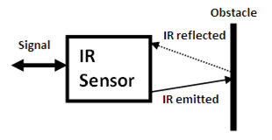

Figure 1: IR Sensor

In this mode, an object is detached when the receiver sees the transmitted source rather than when it fails to see it. Some photo eyes have two different operational types, light operate and dark operate. Light operate photo eyes become operational when the receiver “does not receive” the transmitter signal. The detecting range of a photoelectric sensor is its “field of view”, or the maximum distance the sensor can retrieve information from, minus the minimum distance. A minimum detectable object of minuscule size. PIRs come in many configurations for a wide variety of applications. The most common models have numerous Fresnel lenses or mirror segments, an effective range of about ten meters (thirty feet), and a field of view less than 180 degrees. Models with wider fields of view, including 360 degrees, are available—typically designed to mount on a ceiling.

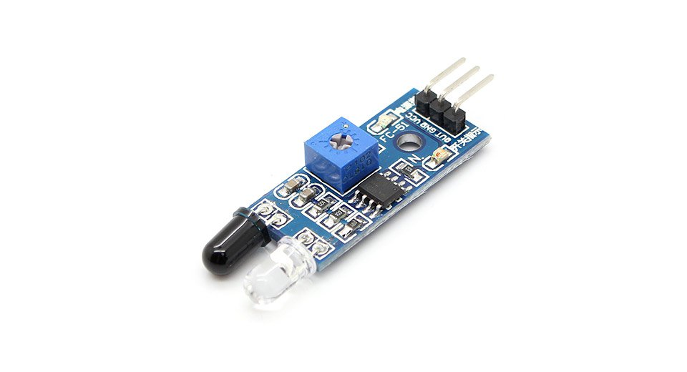

Figure 1.1: INFRARED SENSOR

FEATURES OF PHOTOELECRIC SENSORS

* Long sensing distance

A through-beam sensor, for example, can detect objects more than 10 m away. This is impossible with magnetic, ultrasonic, or other sensing methods.

* Virtually no Sensing object restrictions

These sensors operate on the principle that an object interrupts or reflects light, so they are not limited like proximity sensors to detect metal objects. This means they can be used to detect virtually any object, including glass, plastic, wood and liquid.

* Fast response time

The response time is extremely fast because light travels at high speed and the sensor performs no mechanical operations because all circuits are comprised of electronic components.

* High resolution

The incredibly high resolution achieved with these sensors derives from advanced design technologies that yielded a very small spot beam and a unique optical system for receiving light. These developments enable detecting very small objects, as well as precise position detection.

* Easy adjustment

Positioning the beam on an object is simple with models that emit visible light because the beam is invisible.

* Non contacting sensing

There is little chance of damaging sensing objects orsensors because objects can bedetected without physical contact. This ensure years of sensor services.

**4. POWER SUPPLY**

**4.1 BATTERY**

An electric battery is a device consisting of one or more electrochemical cells with external connections provided to power electrical devices. A battery has a positive terminal, or cathode, and a negative terminal, or anode. The terminal marked positive is at a higher electrical potential energy than is the terminal marked negative. The terminal marked negative is the source of electrons that when connected to an external circuit will flow and deliver energy to an external device. When a battery is connected to an external circuit, electrolytes are able to move as ions within, allowing the chemical reactions to be completed at the separate terminals and so deliver energy to the external circuit. It is the movement of those ions within the battery which allows current to flow out of the battery to perform work. Historically the term "battery" specifically referred to a device composed of multiple cells, however the usage has evolved to additionally include devices composed of a single cell.

Primary (single-use or "disposable") batteries are used once and discarded; the electrode materials are irreversibly changed during discharge. Common examples are the alkaline battery used for flashlights and a multitude of portable devices. Secondary (rechargeable batteries) can be discharged and recharged multiple times; the original composition of the electrodes can be restored by reverse current. Examples include the lead-acid batteries used in vehicles and lithium-ion batteries used for portable electronics.

**4.2 BATTERY CHARGERS**

A battery charger or recharger is a device used to put energy into a secondary cell or rechargeable battery by forcing an electric current through it.

The charging protocol depends on the size and type of the battery being charged. Some battery types have high tolerance for overcharging and can be recharged by connection to a constant voltage source or a constant current source; simple chargers of this type require manual disconnection at the end of the charge cycle, or may have a timer to cut off charging current at a fixed time. Other battery types cannot withstand long high-rate over-charging; the charger may have temperature or voltage sensing circuits and a microprocessor controller to adjust the charging current, determine the state of charge, and cut off at the end of charge.

A trickle charger provides a relatively small amount of current, only enough to counteract self-discharge of a battery that is idle for a long time. Slow battery chargers may take several hours to complete a charge; high-rate chargers may restore most capacity within minutes or less than an hour, but generally require monitoring of the battery to protect it from overcharge. Electric vehicles need high-rate chargers for public access; installation of such chargers and the distribution support for them is an issue in the proposed adoption of electric cars.

Charge and discharge rates are often denoted as C or C-rate, which is a measure of the rate at which a battery is charged or discharged relative to the capacity of the battery. The C-rate is given by the numerical value of the ratio of the charging or discharging current in A to the capacity of the battery in Ah.

For example, for a battery with a capacity of 500mAh, the current corresponding to a C-rate of 10 and a charge or discharge time of 6 minutes would be 5000mA or 5A, while the current corresponding to a C-rate of 1/2 and a charge or discharge time of 2 hours would be 250mA.

Very rapid charging rates, 1 hour or less, generally require the charger to carefully monitor battery parameters such as terminal voltage and temperature to prevent overcharging and damage to the cells.

**4.2.1 TYPES OF BATTERY CHARGERS**

**4.2.1.1 Simple chargers**

A simple charger works by supplying a constant DC or pulsed DC power source to a battery being charged. The simple charger does not alter its output based on time or the charge on the battery. This simplicity means that a simple charger is inexpensive, but there is a tradeoff in quality. Typically, a simple charger takes longer to charge a battery to prevent severe over-charging. Even so, a battery left in a simple charger for too long will be weakened or destroyed due to over-charging. These chargers can supply either a constant voltage or a constant current to the battery.

Simple AC-powered battery chargers have much higher ripple current and ripple voltage than other kinds of battery supplies. When the ripple current is within the battery-manufacturer-recommended level, the ripple voltage will also be well within the recommended level.

The maximum ripple current for a typical 12 V 100 Ah VRLA battery is 5 amps. As long as the ripple current is not excessive (more than 3 to 4 times the battery-manufacturer-recommended level), the expected life of a ripple-charged VRLA battery is within 3% of the life of a constant DC-charged battery.

**4.2.1.2 Fast chargers**

Fast chargers make use of control circuitry in the batteries being charged to rapidly charge the batteries without damaging the cells' elements. Most such chargers have a cooling fan to help keep the temperature of the cells under control. Most are also capable of acting as standard overnight chargers if used with standard NiMH cells that do not have the special control circuitry.

**4.2.1.3 Inductive chargers**

Inductive battery chargers use electromagnetic induction to charge batteries. A charging station sends electromagnetic energy through inductive coupling to an electrical device, which stores the energy in the batteries. This is achieved without the need for metal contacts between the charger and the battery. It is commonly used in electric tooth brushes

and other devices used in bathrooms. Because there are no open electrical contacts, there is no risk of electrocution.

**4.2.1.4 Intelligent chargers**

A "smart charger" should not be confused with a "smart battery". A smart battery is generally defined as one containing some sort of electronic device or "chip" that can communicate with a smart charger about battery characteristics and condition. A smart battery generally requires a smart charger it can communicate with (see Smart Battery Data). A smart charger is defined as a charger that can respond to the condition of a battery, and modify its charging actions accordingly.

Some smart chargers are designed to charge:

• "smart" batteries.

• "dumb" batteries, which lack any internal electronic circuitry.

The output current of a smart charger depends upon the battery's state. An intelligent charger may monitor the battery's voltage, temperature or time under charge to determine the optimum charge current and to terminate charging.

For Ni-Cd and NiMH batteries, the voltage across the battery increases slowly during the charging process, until the battery is fully charged. After that, the voltage decreases, which indicates to an intelligent charger that the battery is fully charged. Such chargers are often labeled as a ΔV, "delta-V," or sometimes "delta peak", charger, indicating that they monitor the voltage change.

The problem is, the magnitude of "delta-V" can become very small or even non-existent if (very) high[quantify] capacity rechargeable batteries are recharged.[citation needed] This can cause even an intelligent battery charger to not sense that the batteries are actually already fully charged, and continue charging. Overcharging of the batteries will result in some cases. However, many so called intelligent chargers employ a combination of cut off systems, which should prevent overcharging in the vast majority of cases.

A typical intelligent charger fast-charges a battery up to about 85% of its maximum capacity in less than an hour, then switches to trickle charging, which takes several hours to top off the battery to its full capacity.

**4.2.1.5 Motion-powered charger**

Linear induction flashlight, charged by shaking along its long axis, causing magnet (visible at right) to slide through a coil of wire (center) to generate electricity

Several companies have begun making devices that charge batteries based on regular human motion. One example, made by Tremont Electric, consists of a magnet held between two springs that can charge a battery as the device is moved up and down, such as when walking. Such products have not yet achieved significant commercial success.

**4.2.1.6 Pulse chargers**

Some chargers use pulse technology in which a series of voltage or current pulses is fed to the battery. The DC pulses have a strictly controlled rise time, pulse width, pulse repetition rate (frequency) and amplitude. This technology is said to work with any size, voltage, capacity or chemistry of batteries, including automotive and valve-regulated batteries. With pulse charging, high instantaneous voltages can be applied without overheating the battery. In a Lead–acid battery, this breaks down lead-sulfate crystals, thus greatly extending the battery service life. Several kinds of pulse charging are patented. Others are open source hardware.

Some chargers use pulses to check the current battery state when the charger is first connected, then use constant current charging during fast charging, then use pulse charging as a kind of trickle charging to maintain the charge.

Some chargers use "negative pulse charging", also called "reflex charging" or "burp charging". Such chargers use both positive and brief negative current pulses. There is no significant evidence, however, that negative pulse charging is more effective than ordinary pulse charging.

**4.2.1.7 Solar chargers**

Solar chargers convert light energy into DC current. They are generally portable, but can also be fixed mount. Fixed mount solar chargers are also known as solar panels. Solar panels are often connected to the electrical grid, whereas portable solar chargers are used off-the-grid (i.e. cars, boats, or RVs).

**4.2.1.8 Timer-based (HI) chargers**

This section does not cite any sources. Please help improve this section by adding citations to reliable sources. Unisource material may be challenged and removed.

The output of a timer charger is terminated after a pre-determined time. Timer chargers were the most common type for high-capacity Ni-Cd cells in the late 1990s for example (low-capacity consumer Ni-Cd cells were typically charged with a simple charger). Often a timer charger and set of batteries could be bought as a bundle and the charger time was set to suit those batteries. If batteries of lower capacity were charged then they would be overcharged, and if batteries of higher capacity were charged they would be only partly charged. With the trend for battery technology to increase capacity year on year, an old timer charger would only partly charge the newer batteries.

Timer based chargers also had the drawback that charging batteries that were not fully discharged, even if those batteries were of the correct capacity for the particular timed charger, would result in over-charging.

**4.2.1.9 Trickle chargers**

A trickle charger is typically a low-current (5–1,500 mA) battery charger. A trickle charger is generally used to charge small capacity batteries (2–30 Ah). These types of battery chargers are also used to maintain larger capacity batteries (> 30 Ah) that are typically found on cars, boats, RVs and other related vehicles. In larger applications, the current of the battery charger is sufficient only to provide a maintenance or trickle current (trickle is commonly the last charging stage of most battery chargers).

Depending on the technology of the trickle charger, it can be left connected to the battery indefinitely. Some battery chargers that can be left connected to the battery without causing the battery damage are also referred to as smart or intelligent chargers. These trickle chargers are typically found on cars, boats, RVs and other related vehicles. These chargers are not effected by any environmental condition and it can provide power to the batteries constantly. With this kind of chargers the batteries can be always kept powered and it also provides a good efficiency.

**4.2.1.10 Universal battery charger**

The most sophisticated types are used in critical applications (e.g. military or aviation batteries). These heavy-duty automatic “intelligent charging” systems can be programmed with complex charging cycles specified by the battery maker. The best are universal (i.e. can charge all battery types), and include automatic capacity testing and analyzing functions too.

**4.2.1.11 USB-based chargers**

Since the Universal Serial Bus specification provides for a five-volt power supply, it is possible to use a USB cable to connect a device to a power supply. Products based on this approach include chargers for cellular phones, portable digital audio players, and tablet computers. They may be fully compliant USB peripheral devices adhering to USB power discipline, or uncontrolled in the manner of USB decorations.

Although portable solar chargers obtain energy from the sun only, they still can (depending on the technology) be used in low light (i.e. cloudy) applications. Portable solar chargers are typically used for trickle charging, although some solar chargers (depending on the voltage), can completely recharge batteries. Other devices may exist, which combine this with other sources of energy for added recharging efficacy.

**4.2.1.12 Power bank**

A typical USB power bank with the cover is used. The internal 18650 sizelithium-ion battery is exposed.

Power banks are mostly popular for charging smartphones and mobile tablet devices. A power bank is a portable device that can supply USB power using stored energy in its built-in batteries. Power banks usually recharge with USB power supply. Basically, power banks comprises the rechargeable batteries, consisting of either Lithium-ion or Lithium-Polymer cells and comes under protective casing, guided by sophisticated PCB ensuring various protective and safety measures. Portable power bank are comprised of a special battery in a special case with special circuit to control power flow. They allow us to store electrical energy and then later use it to charge up a mobile device.

**Specifications:**

• Capacity in mAh:[13] mAh stands for milli Ampere-hour and measures the amount of power flow that can be supplied by a certain powerbank. Amount of mA × time at 5V ideally. Many manufacturers measure this at the voltage of battery inside, hence they show more than actual.

• Simultaneous charging and discharging: need to specify if the powerbank can be used while it is charging.

• Number of output USB ports: This specifies the number of devices that can be charged simultaneously.

• Output current rating: This specifies the current rating that it can charge maximum. The higher the number, better the powerbank. This can vary from output port to output port.

• Input Current Rating: Input current rating is the amount of current the powerbank is able to draw at its maximum level while getting charged.

• Safety Protections: Over Voltage Protection, Over Charge Protections, Over Current Protections, Over Heat Protections, Short-Circuit Protections and Over Discharge Protections are the common safety measures observed with standard powerbanks.

• LED Indications: The Led glows as per indicating the amount of charging ability left with the powerbank.

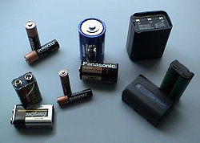

**Figure 2: BATTERIES (DC POWER)**

**5**. **ULTRASONIC SENSOR**

5.1 Introduction

Ultrasonic transducers are transducers that convert ultrasound waves to electrical signals or vice versa. Those that both transmit and receive may also be called ultrasound transceivers; many ultrasound sensors besides being sensors are indeed transceivers because they can both sense and transmit. These devices work on a principle similar to that of transducers used in radar and sonar systems, which evaluate attributes of a target by interpreting the echoes from radio or sound waves, respectively.   
 Ultrasonic sensing techniques have become mature and are widely used in the various fields of engineering and basic science. Actually, many types of conventional ultrasonic instruments, devices and sophisticated software are commercialized and used for both industrial and medical applications. One of advantages of ultrasonic sensing is its outstanding capability to probe inside objectives nondestructively because ultrasound can propagate through any kinds of media including solids, liquids and gases except vacua. In typical ultrasonic sensing the ultrasonic waves are travelling in a medium and often focused on evaluating objects so that a useful information on the interaction of ultrasonic energy with the objects are acquired as ultrasonic signals that are the wave forms variations with transit time.

Such ultrasonic data provides the fundamental basis for describing the outputs of ultrasonic sensing and evaluating systems. In this chapter the fundamentals of ultrasonic sensing techniques are described. What is ultrasound, how to produce and capture ultrasound, what kinds of methods and equipments can be used to measure ultrasound, and what kinds of information can be obtained from ultrasonic measurements? These questions are addressed in the following sections and the answers to the questions are briefly explained from the viewpoint of industrial applications. In addition, some specialized results using a buffer rod sensor that is an effective means for high temperature ultrasonic measurements are introduced to demonstrate its applicability for non destrucive evaluations and monitoring.

**5.2 Working of Ultrasonic sensor**

Active ultrasonic sensors generate high-frequency sound waves and evaluate the echo which is received back by the sensor, measuring the time interval between sending the signal and receiving the echo to determine the distance to an object. Passive ultrasonic sensors are basically microphones that detect ultrasonic noise that is present under certain conditions, convert it to an electrical signal, and report it to a computer.

Ultrasonic probes and ultrasonic baths are used apply sound energy to agitate particles in a wide range of laboratory applications.

**5.3 Specifications**

* Detecting Range is about 3cm to 4.5m.
* Detection Angle :30 degree
* Power supply :5v dc supply
* Ultrasonic frequency :40 kHz
* Trigger pulse width :10 µs
* Global current consumption :15 mA

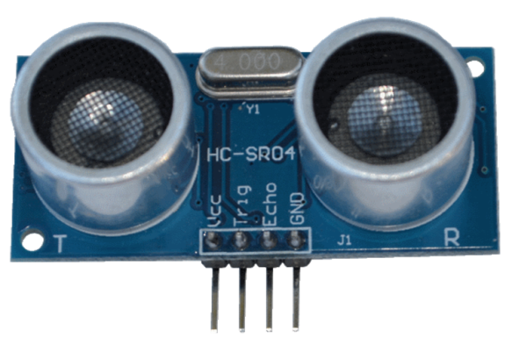

**Figure 3: ULTRASONIC SENSOR**

**6. BLUETOOTH MODULE**

**6.1 INTRODUCTION**

The HC-05 Bluetooth Module [Product link] can be used in a Master or Slave configuration, making it a great solution for wireless communication. You can use it simply for a serial port replacement to establish connection between MCU and GPS, PC to your embedded project, etc.

Bluetooth is a technology for wireless communication, it is designed to replace cable connections. Usually, it connects small devices like mobile phones, PDAs and TVs using a short-range wireless connection. And it uses the 2.45 GHz frequency band. The connection can be point to point or multipoint .where the maximum range is 30meters. The transfer rate of the data is 1Mbps or maximum of 2Mbps.ssssss

**HC-05** Module is an easy to use Bluetooth spp (Serial port protocol) module, designed for transparent wireless serial connection setup. It is an serial port Bluetooth, drop in replacement for wired serial connections. Use it simply for a serial port replacement to establish connection between MCU and GPS, PC.

**6.2 FEATURES:**

[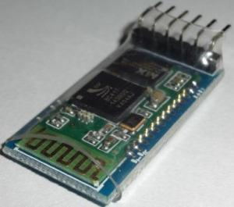](http://i0.wp.com/wiki.jmoon.co/wp-content/uploads/2014/11/JMBLHC05-1.jpg)

**Figure 4: HC-05 Bluetooth Module**

• Protocol: Bluetooth Specification v2.0+EDR

• Frequency: 2.4GHz ISM band

• Modulation: GFSK

• Emission power: ≤4dBm, Class 2

• Sensitivity: ≤-84dBm at 0.1% BER

• Speed: Asynchronous: 2.1Mbps(Max) / 160 kbps, Synchronous: 1Mbps/1Mbps

• Security: Authentication and encryption

• Profiles: Bluetooth serial port

• Power supply: +3.3VDC 50mA

• Working temperature: -20 ~ +75 Centigrade

**6.3 DESCRIPTION**:

The HC-05 Bluetooth Module has 6 pins- Vcc, GND, TX, RX, Key, and LED. It comes pre-programmed as a slave, so there is no need to connect the Key pin, unless you need it change it to Master Mode.

The major difference between Master and Slave modes is that, in Slave mode the Bluetooth module cannot initiate a connection, it can however accept incoming connections. After the connection is established the Bluetooth module can transmit and receive data regardless of the mode it is running in. If you are using a phone to connect to the Bluetooth module, you can simply use it in the Slave mode. The default data transmission rate is 9600kbps.

It has 6 leads in this module. But genuinely care about only four of them. Where, the two are for vcc and GND.VCC=power supply(in other words 5V or 3.3V). GND=Ground or 0Volt. And the next two leads are for RX(Receiving end) and TX(ransmitting end).

RX of the module will go to the TX of the Arduino UNO. In the same way ,we connect the TX of the module with the RX of the Arduino UNO. In addition , can add a LED to determine the output more correctly. So add a LED to digital pin12.

The range for Bluetooth communication is usually 30m or less. The module has a factory set pin of “1234” which is used while pairing the module to a phone.

**PIN CONNECTIONS**:

HC-05 GND Vcc TX RX Key LEDArduino GND 3.3V/5V RX/SoftRx TX/SoftTx _______

|  |  |  |
| --- | --- | --- |
| **S.NO** | **Features** | **Implementation** |
| 1 | Power supply | +3.3VDC 5Ma |
| 2 | Power saving | <4dBm, class 2 |
| 3 | Frequency bands | 2.4GHz ISM band |
| 4 | Modulation | GFSK(Gaussian Frequency Shift Keying |
| 5 | Sensitivity | <-8.4dBm at 0.1%BER |
| 6 | Speed | Asynchronous:2.1Mbps/160kbps  Synchronous:1Mbps/1Mbps |
| 7 | Temperature range | -20 to +75 centigrade |
| 8 | Dimensions | 26.9mm*13mm*2.2mm |
| 9 | Security | Authentication and encryption |
| 10 | Profile | Bluetooth serial port |

**6.4 WORKING**

To understand how a Bluetooth connection works, we need an example of the wireless technology being used, so let’s take a phone connected to wireless speaker. First, each device is equipped with Bluetooth connectivity, a feature that requires both software and hardware components. On the hardware side, an antenna-equipped chip in both devices sends and receives signals at a specific frequency. The software interprets incoming Bluetooth signals and sends them out in ways other devices can read and understand. In the case of the wireless speaker, the phone will know how to send audio files and information in a format that the speaker understands, while the speaker can interpret these signals–as well as other indicators such as volume and track controls–from the phone.

When two devices are equipped with Bluetooth, usually one of them will to be set to be discoverable, meaning it’ll show up in a list of Bluetooth devices in the area on your phone or other controlling device. Using our example, the wireless speaker would be discoverable, and it will end up being controlled by a Bluetooth-equipped phone or remote. The speaker, or any Bluetooth accessory, sends out a signal with a little bit of information to alert other nearby devices of its presence and capabilities. You tell your phone to connect, and the two devices form a personal area network, or piconet.

From this point on, the two devices know to connect with each other based on the unique address within their respective signals. No matter what other signals come in on wavelengths in which those devices operate operate, they will always detect, read, and send the correct signals. Bluetooth signals have a limited range, which prevents massive amounts of conflicting data covering huge areas and interrupting communication between other devices.

**7. MOTOR DRIVER**

**7.1 INTRODUCTION**

L293D is a Motor driver integrated circuit which is used to drive DC motors rotating in either direction. It is a 16-pin IC which can control a set of two DC motors simultaneously. The L293D uses 5V for its own power and external power source is neeThe L293D works on the concept of typical H-bridge, a circuit which allows the high voltage to be flown in either direction. In a single L293D IC there two H-bridge circuits which can rotate two DC motors independently. Due to its size and voltage requirement, it is frequently used in robotics applications for controlling DC motors, including in Arduino projects. The L293D is also a key component in larger 'motor driver' boards available premade for hobbyists.ded to drive the motors, which can be up to 36V and draw up to 600mA.

**7.2 DESCRIPTION**

There are two Enable pins on L293D. Pin 1 (left H-bridge) and pin 9 (right H-bridge). To drive the corresponding motor, pin 1 or 9 need to be set to HIGH. If either pin 1 or pin 9 goes low then the motor in the corresponding section will suspend working.

The four Input pins for the L293D are pin 2 and 7 on the left and pin 15 and 10 on the right as shown on the pin diagram. Left input pins will regulate the rotation of motor connected on the left side and right input for motor on the right hand side. The motors are rotated on the basis of the inputs provided at the input pins as LOGIC 1 or LOGIC 0.

**7.3 WORKING**

A DC motor is any of a class of electrical machines that converts direct current electrical power into mechanical power. The most common types rely on the forces produced by magnetic fields. Nearly all types of DC motors have some internal mechanism, either electromechanical or electronic, to periodically change the direction of current flow in part of the motor. Most types produce rotary motion; a linear motor directly produces force and motion in a straight line.

DC motors were the first type widely used, since they could be powered from existing direct-current lighting power distribution systems. A DC motor's speed can be controlled over a wide range, using either a variable supply voltage or by changing the strength of current in its field windings. Small DC motors are used in tools, toys, and appliances. The universal motor can operate on direct current but is a lightweight motor used for portable power tools and appliances. Larger DC motors are used in propulsion of electric vehicles, elevator and hoists, or in drives for steel rolling mills.

**7.4 SPECIFICATIONS**

* Voltage range :4.5v to 36v
* Current :100 mA to drive motor
* Max resistance :60 Ώs
* o/p current capability :600 mA
* Pulsed current : 1.2 mA per drive.
* Package :16 pin DIP
* Ic weight :2 gram

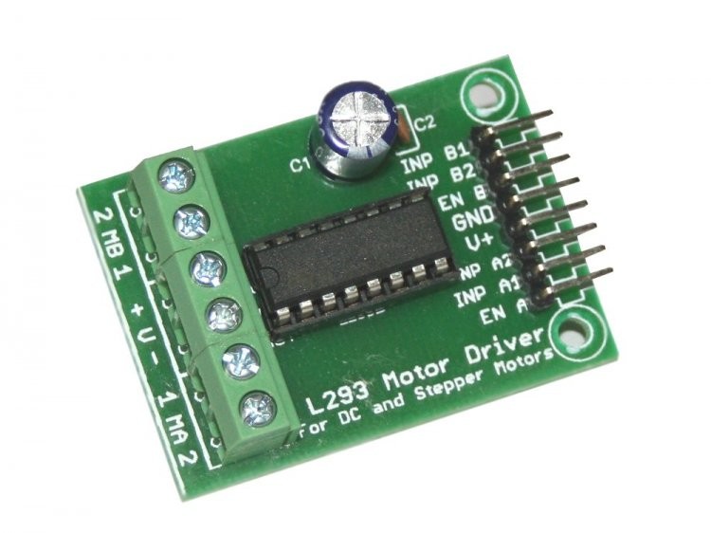

**Figure 5: MOTOR DRIVER**

**8. ARDUINO UNO**

8.1 Introduction of Arduino

[Arduino](http://arduino.cc/) is an open-source platform used for building electronics projects. Arduino consists of both a physical programmable circuit board (often referred to as a [microcontroller](http://en.wikipedia.org/wiki/Microcontroller)) and a piece of [software](http://arduino.cc/en/Main/Software), or IDE (Integrated Development Environment) that runs on your computer, used to write and upload computer code to the physical board.

The Arduino platform has become quite popular with people just starting out with electronics, and for good reason. Unlike most previous programmable circuit boards, the Arduino does not need a separate piece of hardware (called a programmer) in order to load new code onto the board – you can simply use a USB cable. Additionally, the Arduino IDE uses a simplified version of C++, making it easier to learn to program. Finally, Arduino provides a standard form factor that breaks out the functions of the micro-controller into a more accessible package.

8.2 General use of Arduino

The Arduino hardware and software was designed for artists, designers, hobbyists, hackers, newbies, and anyone interested in creating interactive objects or environments. Arduino can interact with buttons, LEDs, motors, speakers, GPS units, cameras, the internet, and even your smart-phone or our TV. This flexibility combined with the fact that the Arduino software is free, the hardware boards are pretty cheap, and both the software and hardware are easy to learn has led to a large community of users who have contributed code and released instructions for a **huge** variety of Arduino-based projects.

For everything from [robots](https://learn.sparkfun.com/tutorials/building-the-hub-ee-buggy) and a [heating pad hand warming blanket](https://learn.sparkfun.com/tutorials/heating-pad-hand-warmer-blanket) to [honest fortune-telling machines](https://learn.sparkfun.com/tutorials/the-uncertain-7-cube),  [Dragons dice-throwing gauntlet](http://www.sparkfun.com/tutorials/333), the Arduino can be used as the brains behind almost any electronics project.

**8.3 General features of Arduino Uno**

Arduino Uno is one of the types belongs to the Arduino family. It has 14 digital input/output pins (of which 6 can be used as PWM outputs), 6 analog inputs, a USB connection, a power jack, a reset button and more. It contains everything needed to support the microcontroller; simply connect it to a computer with a USB cable or power it with a AC-to-DC adapter or battery to get started.

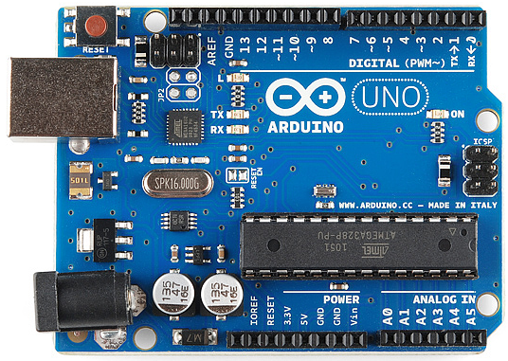

Figure 6: Arduino UNO

8.4 Power (USB/ Barrel Jack)

Every Arduino board needs a way to be connected to a power source. The Arduino UNO can be powered from a USB cable coming from the computer or a wall power supply that is terminated in a barrel jack.

 Do not use a power supply greater than 20 Volts because the Arduino will get damaged. The recommended voltage for most Arduino models is between 6 and 12 Volts.

### 8.5 Pins (5V, 3.3V, GND, Analog, Digital, PWM, AREF)

The pins on Arduino are the places where the wires can be connected to construct a circuit probably in conjunction with a [breadboard](https://learn.sparkfun.com/tutorials/how-to-use-a-breadboard/) and some [wire](https://learn.sparkfun.com/tutorials/working-with-wire). They usually have black plastic ‘headers’ that allows to just plug a wire right into the board. The Arduino has several different kinds of pins, each of which is labeled on the board and used for different functions.

* **GND:** Short for ‘Ground’. There are several GND pins on the Arduino, any of which can be used to ground the circuit.
* **5V & 3.3V:** The 5V pin supplies 5 volts of power and the 3.3V pin supplies 3.3 volts of power. Most of the simple components used with the Arduino run happily off of 5 or 3.3 volts.
* **Analog:** The area of pins under the ‘Analog In’ label (A0 through A5 on the UNO) is Analog In pins. These pins can read the signal from an analog sensor (like a [temperature sensor](https://www.sparkfun.com/products/10988)) and convert it into a digital value that we can read.
* **Digital:** Across from the analog pins are the digital pins (0 through 13 on the UNO). These pins can be used for both digital input (like telling if a button is pushed) and digital output (like powering an LED).
* **PWM:** The tilde (~) next to some of the digital pins (3, 5, 6, 9, 10, and 11 on the UNO) act as normal digital pins, but can also be used for something called Pulse-Width Modulation (PWM).

8.6 RESET Button

Arduino has a reset button. Pushing it will temporarily connect the reset pin to ground and restart any code that is loaded on the Arduino.

8.7 Power LED Indicator

The LED in the Arduino board should light up whenever Arduino is plugged into a power source. If this light doesn’t turn on, then it means that there is some problem with the power supply and the board.

8.8 TX and RX LED Indicators

TX is short for transmit, RX is short for receive. These markings appear quite a bit in electronics to indicate the pins responsible for [serial communication](https://learn.sparkfun.com/tutorials/serial-communication). There are two places on the Arduino UNO where TX and RX appear – once by digital pins 0 and 1, and a second time next to the TX and RX indicator LEDs. These LEDs will give us some nice visual indications whenever our Arduino is receiving or transmitting data.

8.9 Main IC

The black thing with all the metal legs is an IC, or Integrated Circuit. Think of it as the brains of our Arduino. The main IC on the Arduino is slightly different from board type to board type, but is usually from the ATmega line of IC’s from the ATMEL Company.

8.10 Voltage regulator

The voltage regulator is not actually something you can (or should) interact with on the Arduino. The voltage regulator controls the amount of voltage that is let into the Arduino board. Think of it as a kind of gatekeeper; it will turn away an extra voltage that might harm the circuit.

**9. DC MOTOR**

**9.1 INTRODUCTION**

Synchronous motors are like induction motor in that they both have stator windings to produce a rotating magnetic field. It has speed of 60RPM AC Synchronous Motors ranging from 3 kg-cm Torque at 60 RPM at 50HZ to 80 kg-cm Torque at 60 RPM at 50HZ. With high grade aluminium casing, SS shaft, high grade stamping, high grade copper winding and high quality ball bearings.

Normally the synchronous motors ranges were size from sub-fractional horsepower to 10,000 horsepower (HP).Similarly small synchronous motor is mainly used for the household device like timer, fans etc. Large synchronous motors are used in process industries and drive equipment.

**9.2 SPECIFICATION**

* Operating range : 3v to 12volts
* Nominal voltage : 12v
* No load speed : 5000 rpm
* No load current : 0.022A
* Max efficiency speed : 4906 rpm
* Max torque : 21.1 g.cm
* Weight : 50 gram
* Operating temp : -10⁰c to 60⁰c

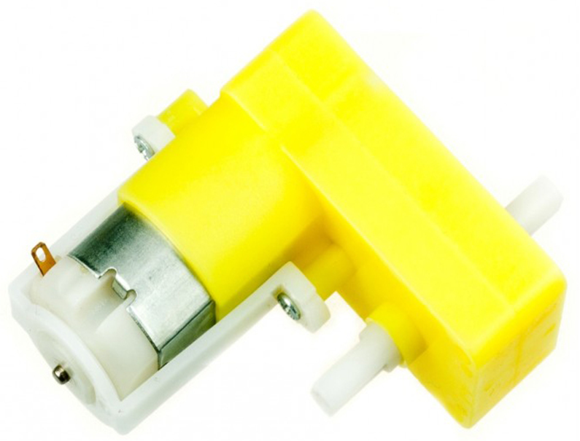

**Figure 7: DC GEAR MOTOR**

**9.3 WORKING**

A motor is an electrical machine which converts electrical energy into mechanical energy. The principle of working of a DC motor is that "whenever a current carrying conductor is placed in a magnetic field, it experiences a mechanical force". The direction of this force is given by Fleming's left hand rule and it's magnitude is given by F = BIL. Where, B = magnetic flux density, I = current and L = length of the conductor within the magnetic field.

Fleming's left hand rule: If we stretch the first finger, second finger and thumb of our left hand to be perpendicular to each other AND direction of magnetic field is represented by the first finger, direction of the current is represented by second finger then the thumb represents the direction of the force experienced by the current carrying conductor.

When armature windings are connected to a DC supply, current sets up in the winding. Magnetic field may be provided by field winding (electromagnetism) or by using permanent magnets. In this case, current carrying armature conductors experience force due to the magnetic field, according to the principle stated above.

Commutator is made segmented to achieve unidirectional torque. Otherwise, the direction of force would have reversed every time when the direction of movement of conductor is reversed the magnetic field.

While a dc generator converts mechanical energy in the form of rotation of the conductor(armature) into electrical energy, a motor does the opposite. The input to dc motor is electrical and the output is mechanical rotation or torque.

DC series motor motors, the field winding is connected in series with armature.the field winding should have less number of turns of wire. The resistance of the series field winding should be very small.

**9.3.1 Back EMF**

According to fundamental laws of nature, no energy conversion is possible until there is something to oppose the conversion. In case of generators this opposition is provided by magnetic drag, but in case of dc motors there is back emf.

When the armature of the motor is rotating, the conductors are also cutting the magnetic flux lines and hence according to the Faraday's law of electromagnetic induction, an emf induces in the armature conductors. The direction of this induced emf is such that it opposes the armature current (Ia) . The circuit diagram below illustrates the direction of the back emf and armature current. Magnitude of Back emf can be given by the emf equation of DC generator.

**9.3.2 Significance of Back emf:**

Magnitude of back emf is directly proportional to speed of the motor. Consider the load on a dc motor is suddenly reduced. In this case, required torque will be small as compared to the current torque. Speed of the motor will start increasing due to the excess torque. Hence, being proportional to the speed, magnitude of the back emf will also increase. With increasing back emf armature current will start decreasing. Torque being proportional to the armature current, it will also decrease until it becomes sufficient for the load. Thus, speed of the motor will regulate.

On the other hand, if a dc motor is suddenly loaded, the load will cause decrease in the speed. Due to decrease in speed, back emf will also decrease allowing more armature current. Hence, being proportional to the speed, magnitude of the back emf will also increase. The direction of this induced emf is such that it opposes the armature current. Increased armature current will increase the torque to satisfy the load requirement. Hence, presence of the **back emf makes a dc motor ‘self-regulating’**.

**10. HARDWARE IMPLEMENTATION**

The car first asks for the mode at which it have to be operated. When the user gives the mode of operation as voice control, he have to speak the instruction to the mobile phone according to the data sheet, for example the instruction you have to give is left, you speak to the mobile as ‘L’ so that the car hears the users instruction and moves left side.

For operating the car in voice control alone one needs the data connection available in the mobile which is going to control. Secondly for operating in the automatic mode just enter ‘A’ in the mobile and the car will be operating in the automatic mode, when any obstacle is present in the front of the car, then the car will take right as our country standard is to over take a vehicle in the right side of the opposite car. Likewise when any other obstacle is present in the either side of the car it will sense the that too and take the control action accordingly.

In the obstacle located at all the three sides of the car (ie) at the front, left and

Right side of the car, the car will take the backward direction just for three seconds and turns towards right for the same three seconds. At this condition alone the programmer have made the car to be operated in back and right so that only this is mode is named as semi automatic mode.

After the semi automatic mode senses the back after that it will continues the same actions. Once if the operated wanted to operate the vehicle in manual mode, they have to press f, r, l, b, s, m Front, Right, Left, Back, Stop and Fast respectively, these are control codes programed by the programmer which can be changed in the future.

To select the mode and to change the direction and speed of the vehicle all the users have to have is only one thing. The users should have an android mobile phone installed with blueterms application. This app is compatible to Android platform only, ios users have no other choice to operate the vehicle without the help of the android users. The hardware structure of our project consists a chassis attached with ultrasonic sensors in rear and front. The purpose of the ultrasonic sensor is to measure the distance of the vehicles within the specified range.

Infrared sensors are placed on the right and left on the front end of the vehicle. It serves the purpose of detecting the obstacles while the vehicle is turning left and right. If we see through the top view of the object we can find a motor driver, Arduino uno board. The purpose of the motor driver is to drive the motor.

Once when you enter into the blueterms app, the user have to connect the car with their mobile into the blueterms app. There the car will ask the user to enter the password to connect the mobile with the car. The password which the user have to enter is highly confidential to the users alone and it can be changed by the users if required.

The person without knowing the password one cannot operate the vehicle. Once if the authorized user forgets the password there is no other go we have to re-program the vehicle. The vehicle can be changed to any of the modes at any situations as the switching time of the vehicle is very much less so that it will not be failed at any point.

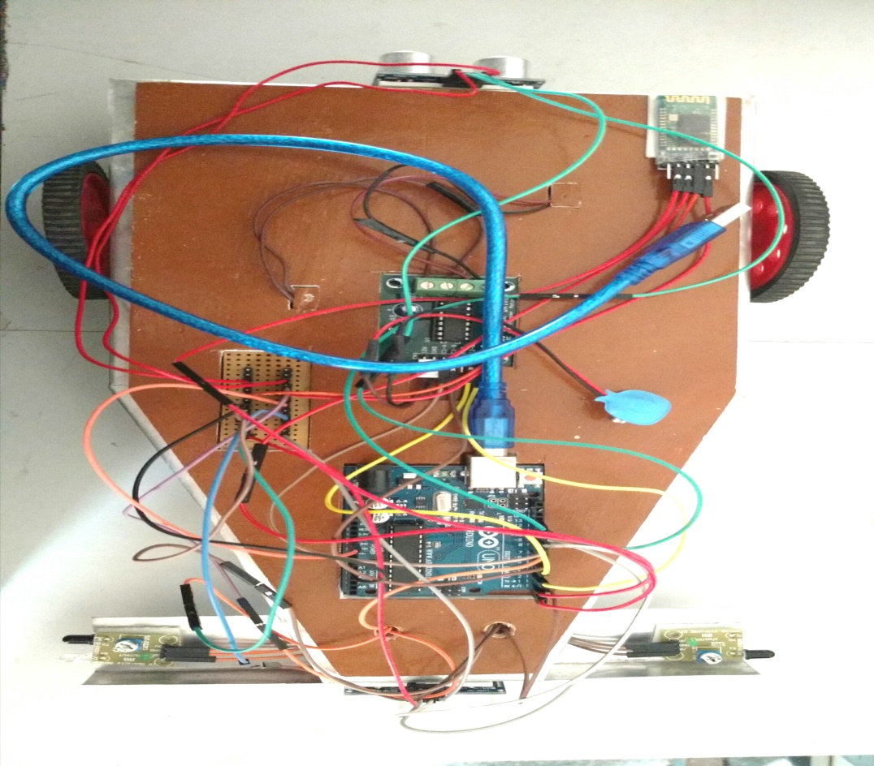

**Figure 8: Final outlook**

**11. PROGRAMMING OF ARDUINO**

**11.1 ALGORITHM:**

1) Turn on the vehicle.

2) Connect the mobile with the vehicle.

3) Enter the password.

4) Select any one mode of operation.

5) The modes are

1) Semi-automatic mode

2) voice control mode

3) Mobile operated mode.

6) If semi-automatic mode selected with the help of 2 ultrasonic sensors and 2 IR sensors, the vehicle will operate itself with an efficient and clear manner.

7) When voice control mode is selected speak the required control words to operate the vehicle, but for the voice control mode alone, network connection is necessary.

8) For mobile controlled mode, type the respected control inputs to operate the vehicle, the response time is good.

9) Switching from one mode to other mode is very simple (i.e.) A- automatic, V- voice controlled, F- front, B- back, L- left, r-right, s-stop.

**FLOWCHART:**

Start

Otherwise

Select the mode

**F**

Front mode

(Slowly)

Select correct mode

**M**

Front Mode

( fastly )

**R**

Turn Right

**L**

Turn Left

**B**

Back side

**V**

Voice mode

Automatic mode

**A**

**S**

Stop

**CONT........**

**A**

Automatic mode

**Yes Yes**

D1>30

IR1&IR2

Alone high

IR1&IR2

Alone high

**No**

**No No**

**Yes**

Front

Front fast

Front

**Yes**

Move left (or) right

D1<25

**Yes Yes**

IR1&IR2

Alone high

D2>15

**Yes No**

**Yes No**

stop

**Yes**

Move left (or) right

Back

Lock

**CONT.......**

**V**

**Otherwise**

Voice mode

**F**

Front (slow)

Front (fast)

**M**

**R**

Right

**L**

Left

B

Back

**S**

Stop

**12. ADVANTAGES:**

1. Man power is reduced

2. The driver can have smooth drive automatically

3. It is cost effective

4. Physically challenged people can use the vehicle with ease.

**13. DISADVANTAGES:**

1. If there is any malfunction in the vehicle in any of the four sensors the system fails in its operation.

2. At an instance the programmer have to drive the vehicle manually

**14. CONCLUSION**

This project is made for aiding the physically challenged people and for bringing them the vehicle that they can drive smoothly like any other normal people in the world. This project extends bringing the revolution in the automation with several advantages and overcoming the drawbacks in the existing model. The project is not only for the physically challenged peoples, everyone can drive this vehicle as per requirement.

**15. FUTURE SCOPE**

This project can bring a greater revolution in the world of automobiles. This project is done mainly in focus to aid physically challenged peoples and if our project comes into the existence, those people can drive the car easily without having any kind of difficulties, because transportation is one of the major problems faced by those physically under privileged peoples. Since the cost of the vehicle is less ,literally humble background people can use this vehicle. This attempt is made for the future use to create a history in the field of automation by overcoming the drawbacks in the current automated vehicle.

REFERENCES

[1] Rajkamal, “**Embedded System Architecture, Programming and Design**”, Tata McGrawhill Publising Company Ltd, Second edition, 2008

[2] John.b.peatman, “**Design with Microcontrollers**”, Pearson Education, 2002.

[3] Tim Wihurst, “**An Introduction to the design of Small Scale Embedded**

**System**”, Palgrave, 2004

[4] Frank Vahid, Tony Givargis, “**Embedded System Design**”, Wiley India, 2006.

[5] Tammy Noergaard, “**Embedded Systems Architecture**”, Elsevier, 2005.

[6] Ajay V. Deshmukh, “**Microcontrollers Theory And Applications**”, Tata McGraw Hill Publising Company Ltd, 2008

[7] Cooper. W. D and Helfrick. A. D, "**Modern Instrumentation and Measurement Techniques**", Third Edition, Prentice-Hall of India, 2008.

[8] Patranabis. D, "**Principles of Electronic Instrumentation**", PHI Learning Pvt Ltd, 2008.

[9] Chesmond, Wilson and Lepla, "**Advanced Control System Technology**", Viva low priced student edition, 1998